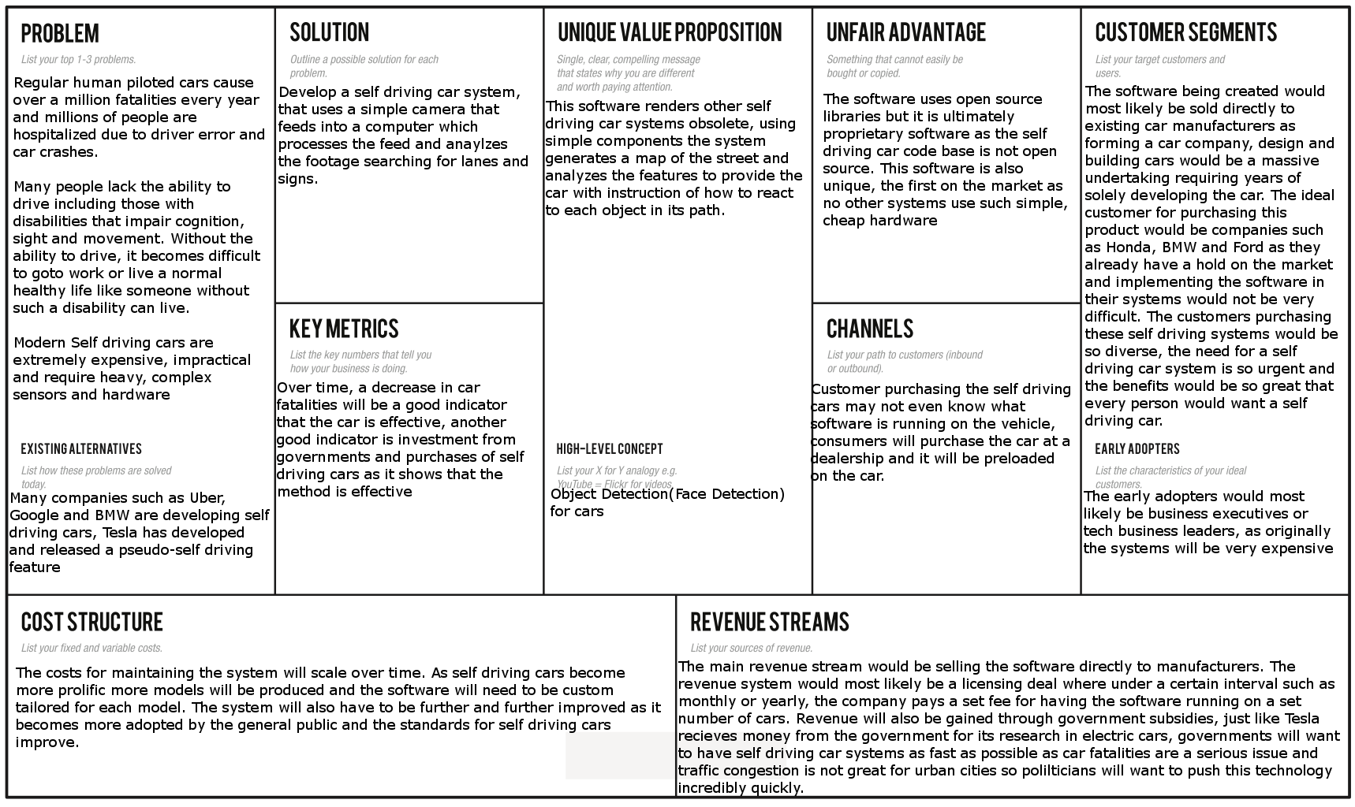

**Description of Product:**

The software I’m making is a video analysis software which intakes a video feed and analyzes the stream for certain features. Currently I am using Python and OpenCV to take an input video feed and analyze it. The part I am developing right now, and which is arguably the hardest part is the lane detection system. This is the hardest part as lanes are almost never completely straight and include things like varying colors, lighting differences as well as dotted lines. Then there is the issue of perspective where a video has a warped perspective and straight lines don’t look straight in a video feed. I am attempting to resolve all these issues using different research papers listed below. I am using methods for detecting curved lanes by using quadratic regression on different points detected on a lane to attempt to get an approximate version of the lane, for the warped perspective of the camera I am attempting to correct that by using OpenCV’s built-in geometric image transformations. The next problem I will be solving is detecting various street signs, pedestrians and lights. I will most likely be using deep learning algorithms such as Tensorflow or the YOLO algorithm to attempt to detect and identify objects. One large issue is that my laptop has a very poor GPU which means framerates may dip when I a attempt to use deep learning analysis however if this was put on a say two thousand dollar computer system in a car which was tailored to compute this then the program would work fine, however for my use case I am attempting to make this as efficient as possible. I aim to finish the curved lane detection by the start of December and begin object identification in December.

**Research Papers on Self Driving Cars**

<https://ieeexplore.ieee.org/abstract/document/1505186>

<https://ieeexplore.ieee.org/abstract/document/1520207>

<https://ieeexplore.ieee.org/abstract/document/5940562/>

https://arxiv.org/abs/1504.01716

**OpenCV Geometric Transformations**

https://docs.opencv.org/2.4/modules/imgproc/doc/geometric_transformations.html